**DS20613 - Assignment 1**

**First Version Submitted on 14 October 2020**

**Revised Version Submitted on 07 November 2020**

**Name:** Theivaprakasham H

**Roll Number:** CB.EN.P2CEN20026

**List of Components**

**Name** **Quantity**  **Component**

U1 1 Arduino Uno R3

D1 1 Green LED

D2 1 Yellow LED

D3 1 Blue LED

D4 1 Red LED

D5 1 White LED

R1

R2

R3

R4

R5 5 10 kΩ Resistor

**Breadboard view:**

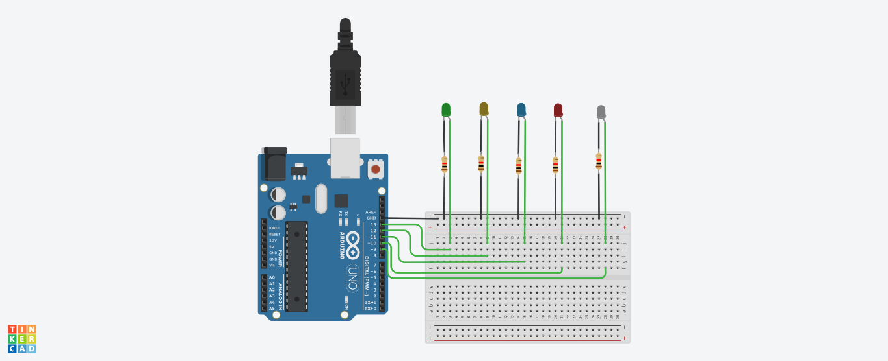

**Code:**

/*

@author: Theivaprakasham H

@title: Blinking 5 LEDs at different rate sequentially

*/

**// Step - 1 - Initialize LED port numbers**

int n[] = {1,2,4,6,8}; //Number of times each LED should Blink

int led[] = {13,12,11,10,9}; //Choosing the Digital LED pins

**// Step - 2 - Initialize the each assigned digital pins as output mode by manipulating DDRB register**

void setup() {

// B – Binary representation

// B 0 0 1 1 1 1 1 0

// Setting

// Digital pins 13 12 11 10 9

// as INPUT/OUTPUT using DDRB Register

DDRB = B00111110;

}

**// Step - 3 - Our Void main loop function which will run for indefinitely**

void loop() {

// First FOR loop is for fetching leds pins

for(int i = 0; i < sizeof(led)/sizeof(led[0]); i++) {

// Second FOR loop is for blinking led N number of times

for(int j = 0; j < n[i]; j++) {

digitalWrite(led[i], HIGH); **// Powers ON led by setting it to HIGH state**

delay(500); **// Hold the LED light in HIGH state for 0.5 seconds**

digitalWrite(led[i], LOW); **// Powers OFF the led by setting it to LOW state**

delay(500); **// Hold the LED light in LOW state for 0.5 seconds**

} } }